Final Information Form for Author(s)/ Presenter(s) ­ ICHSS 2017

Dates of the Event: 28th and 29th of July 2017

Event Address: Faculty of Arts, University of Peradeniya, Sri Lanka

Contact us at (94)775777033 / (94)812386173

* Required
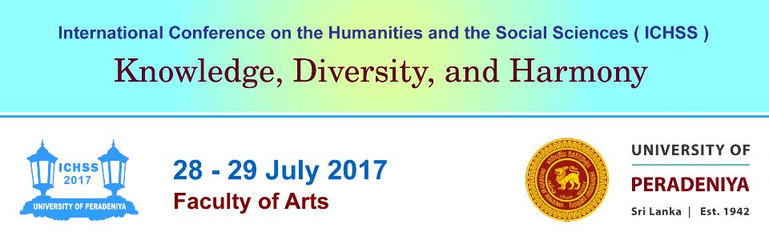

- 1) Title *

Mark only one oval.

Rev.
Prof.
Dr.
Mr.
Mrs.
Miss
Ms.
Other:

2. 2) Name (as you want it to appear on the Certificate) *

- 3) Conference Status *

Mark only one oval.

Presenter
Author
Co­author
Other:

- 4) Institutional Affiliation *

- 5) Email Address *

- 6) Postal Address *

- 7) Contact Number (Telephone/ Mobile) *

- 8) Extended Abstract Number *

- 9) Title of Extended Abstract *

- 10) Do you require multimedia facilities? *

Mark only one oval.

Yes
No

- 11) In addition to general multimedia facilities, do you require any other technical assistance? *
Mark only one oval.

Yes
No

12. If yes, please specify your additional technical requirement/s.
- 12) On what days will you attend ICHSS 2017? *

Check all that apply.

Day 1 (28th of July 2017)
Day 2 (29th of July 2017)
Day 1 and Day 2 (28th & 29th of July 2017)

- 13) Will you be attending the Inaugural Ceremony and the Conference Dinner? *

Mark only one oval.

Inaugural Ceremony only
Conference Dinner only
Inaugural Ceremony and Conference Dinner

- 14) Meal Preference *

Mark only one oval.

Vegetable
Meat
Fish
Egg

Powered by

