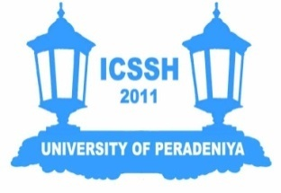
REGISTRATION FORM

THE 1st INTERNATIONAL CONFERENCE ON THE SOCIAL SCIENCES AND THE HUMANITIES
UNIVERSITY OF PERADENIYA, 16th and 17th DECEMBER 2011

Title (Prof/Dr/Mr/Ms/Rev): ……………………………………………………………………………….....................
Full Name (Underline the Surname): ……………………………………………………………………………….....................
Organization/Institution: ……………………………………………………………………………….....................
Mailing Address: ………………………………………………………………………………..................... ……………………………………………………………………………….....................
……………………………………………………………………………….....................

Telephone (Office): ………………………….............. Telephone (Mobile): ……………………....................
E-mail: ……………………………………………………………………………….......................................

2. Participant Category [Please check () as appropriate]

 |  |  | Student Rates (pls mail copy of valid student ID)
 | Local Participant | LKR 3000 |  | Local Student | LKR 1500
 | SAARC Participant | USD 50 |  | SAARC Student | USD 35
 | Non- SAARC Participant | USD 100 |  | Non-SAARC Student | USD 75

2.1 Registration Type [Please check () as appropriate]
 | Presenter |  | Participant

2.2 Conference Dinner (Dec 16th) for Presenters [Please check () as appropriate]
I will attend I will not attend

(Paper Presenters will be hosted by the Conference Organizing Committee).

3. Payments
3.1 Local Participants
Please credit your registration fee to the University of Peradeniya account with the Bank of Ceylon and send your pay-in voucher only by post to the Conference Secretariat (Refer to the Conference website for account information).
3.2 Foreign Participants
Please make your registration fee payment at the registration desk.

Email (icssh.peradeniya@gmail.com) OR post the completed Form to:
Conference Secretariat [ICSSH],
Faculty of Arts,
University of Peradeniya,
Peradeniya,
Sri Lanka.

